## What is a coronavirus?

Coronavirus is type of virus that causes diseases of varying severities, ranging from the common cold to more serious respiratory disease. A novel (new) coronavirus is a new strain of coronavirus that hasn‘t been identified before in humans.

# Who gets coronavirus?

Coronaviruses are normally found in animals but can be spread to humans. Some coronaviruses are also spread from person to person. Recently, thousands of cases of pneumonia associated with a novel coronavirus in China have been identified, along with some in the United States.

# How is coronavirus spread7

Human coronaviruses most commonly spread from an infected person to others through:

* + coughing and sneezing
  + close personal contact, such as touching or shaking hands
  + touching objects or surfaces with the virus on it,

then touching your mouth, nose, or eyes before washing your hands

* + rarely, fecal contamination
  + Novel coronavirus is new, and we are learning more each day about transmission patterns and incubation periods. As information becomes available, we will keep you informed.

People who have traveled to China since December 1, 2019,

could have been exposed to the virus. People should seek medical care if they have traveled to China and develop a fever or respiratory symptoms within 14 days of return. People who have been in close contact with a person who has a confirmed case of novel coronavirus should seek medical care if they develop fever or respiratory symptoms.

## What are the symptoms of the disease?

Symptoms can include:

* + Fever
  + Cough
  + Difficulty breathing
  + Severe illness

Complications and outcomes of this virus are still being investigated.

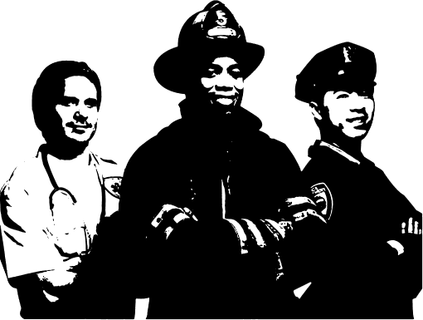

Key Points

* Novel coronavirus is a new

virus that hasn’t been identified before in humans

* Coronaviruses can be spread through close personal contact, or by touching an object or surface with the virus in it
* Use prevention measures that work to prevent other respiratory infections to prevent novel coronavirus
* Public Health is taking steps to prevent the spread of coronavirus in Louisiana.

For **more information**

Louisiana Department of Public Health <http://Idh.la.gov/Coronavirus>

Centers for Disease Control and Prevention (CDC) <http://www.cdc.qov/coronavirus/> novel coronavirus 2019.html

World Health Organization <http://www.who.int/health> topics/coronavirus

# How is novel coronavirus a threat?

There is no specific treatment for illness caused by novel coronavirus. However, many of the symptoms can be treated. Treatment will be based on the patient’s condition. There is no vaccine for novel coronavirus.

# How can first responders protect themselves from infection?

Routine exposure control precautions as with any respiratory illness (Flu/TB/Pneumonia/Etc..) will protect EMS providers. This includes:

* + Obtain an illness and travel history to determine if there has been any travel to areas impacted or close proximity to someone confirmed sick with the virus.
  + As with the flu and other respiratory illness, place a surgical mask on the patient if tolerated.
  + If travel history or risk factors warrant, then the crew should initiate standard contact/airborne/droplet precautions (gloves, gown, N95, eye protection). Also use caution with aerosol generating procedures (neb treatments, suction, etc..).
  + Notify Hospital ED that a potentially infectious patient is enroute.
  + Properly donn/doff/dispose of PPE.
  + Disinfect equipment and unit as per established protocols.

# Since there are cases in the United States, what can I do to protect myself?

Based on current information, even though there are cases in the United States and there are likely to be addtional cases, the risk of transmission of coronavirus in Louisiana remains low. People should continue to engage in their regular activities if they are not ill. As with other respiratory illnesses, there are steps that everyone can take to reduce the risk of getting sick from circulating viruses. This **includes remaining home when ill, washing hands with** soap **and water frequently, covering** coughs and sneezes and get your flu shot.

For more information

**Louisiana Department of Public Health** <http://ldh.la.gov/Coronavirus>

Centers for Disease Control **and Prevention** (CDC) <http://www.cdc.qov/coronavirus/> novel-coronavirus-2019.html

World Health Organization <http://www.who.int/health-> topics/coronavirus